No. of Pages | 3
No. of Questions | 4

Department of Computer Science and Engineering
MIDTERM EXAMINATION SPRING 2010

CSE320: Data Communications
Total Marks: 60 Time Allowed: 1 Hour

- Answer ALL Four (4) questions.
- Figure in bracket [] next to each question indicates marks for that question.

Question No. 1

- What is the difference between OSI and ISO? [3 marks]
- List some functions of the Physical Layer of the TCP/IP model. [2 marks]
- Referring to the figure no. 1 below, Router1 is sending a packet to PC B, state which IP addresses and MAC addresses will be included in the packet (Source & Destination both and for indicating MAC addresses just mention the device or device interface). What if PC A is sending the packet to the PC B? [5.5 marks]
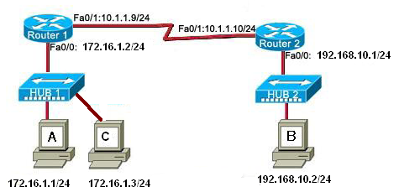
Figure No. 1

- List the layers of TCP/IP model along with examples of protocols, PDU names and addresses used for each layer. [4.5 marks]

Question No. 2

- IP is an unreliable protocol. What does this mean? [3 marks]
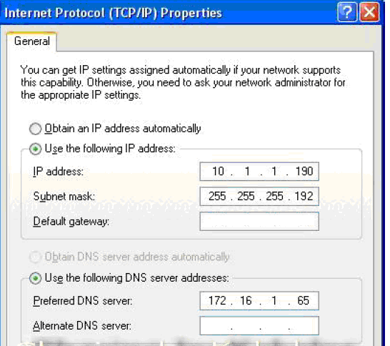
Figure No. 2

- In the above figure no. 2, you are looking at the IP configuration of a PC. Is there any other way of finding the IP configuration of a PC? This PC cannot access anyone outside of its own network, why? [3 marks]

Gateway of last resort is 172.16.2.2 to network 0.0.0.0
200.20.0.0/24 is subnetted, 2 subnets
R 200.20.1.0[120/2] via 172.16.1.2, 00:00:02, serial0/0
C 172.16.1.0/24 is directly connected, serial 0/0
C 172.16.2.0/24 is directly connected, serial 0/1
C 172.16.4.0/24 is directly connected, FastEthernet0/0
C 172.16.3.0/24 is directly connected, FastEthernet0/1
S* 0.0.0.0/0 [1/0] via 172.16.2.2

Figure No. 3

- The above figure no. 3 represents the routing table of a router. The router has how many interfaces? How did you interpret it? What does the route S* represent? [3 marks]
- Using the figure no. 3 above, explain what are static routes and dynamic routes? [4 marks]
- What does the 2 represent in [120/2] item of the routing table? [2 marks]

Question No. 3

- When you write www.yahoo.com in the URL of a web browser, the first packet sent by your PC is to a DNS server, why? How does a PC know where to send the DNS request? [4 marks]
- Do you recommend using DHCP for all devices in a network? [2 marks]
- Compare between P2P and FTP. [3 marks]
- From a PC at the network administrator’s office, you wish to access a switch on another floor to re configure it? Which application allows you to do? [2 marks]
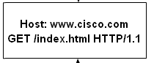
Figure No. 4
- Explain the second line in the above figure no 4. [4 marks]

Question No. 4

  - Name 2 application layer protocols that use TCP and another 2 that use UDP. [2 marks]
  - If TCP is using a window size of 500 bytes, what does this mean? [3 marks]
  - A host sends data using TCP but receives no acknowledgement, what happens next? [3 marks]
  - State two differences between Well-Known port numbers and Dynamic Port numbers. [4 marks]
  - Which control flags/code bits are used during connection establishment in TCP? State their purpose in one line. [3 marks]

